**Login Page:**

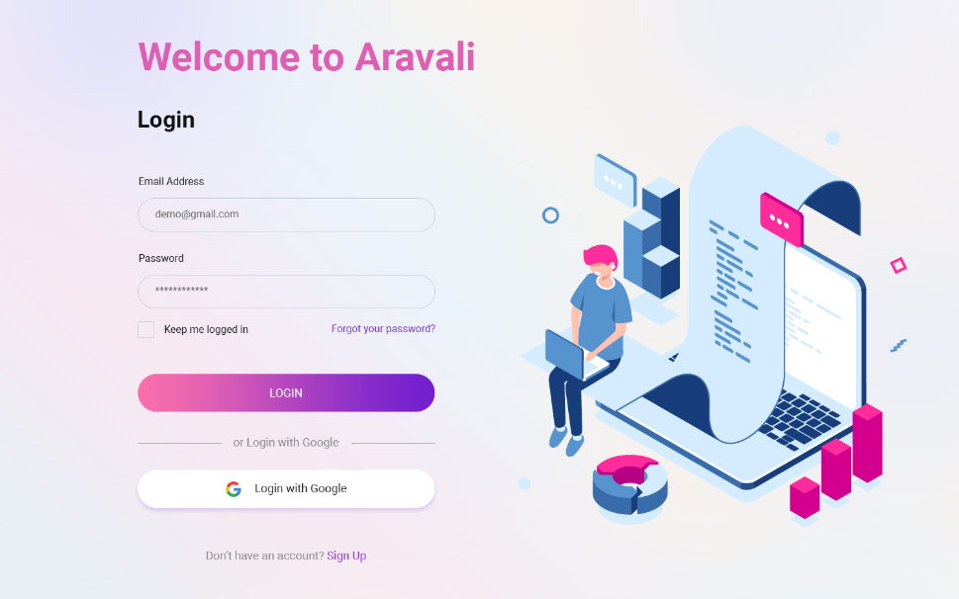

**Main Dashboard:**

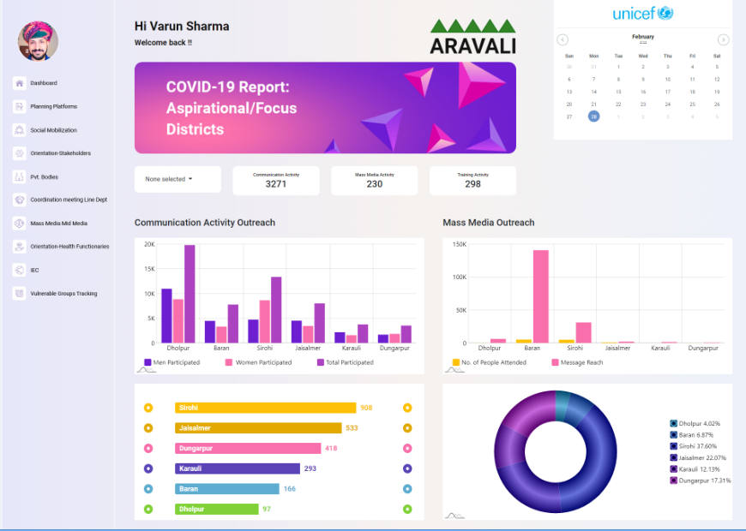

**Planning Platform >> DTF/DHS Meeting :**

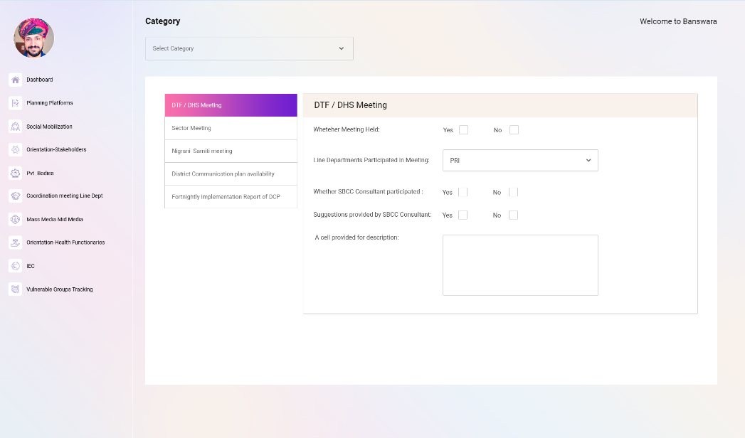

**Planning Platform >> Sector Meeting :**

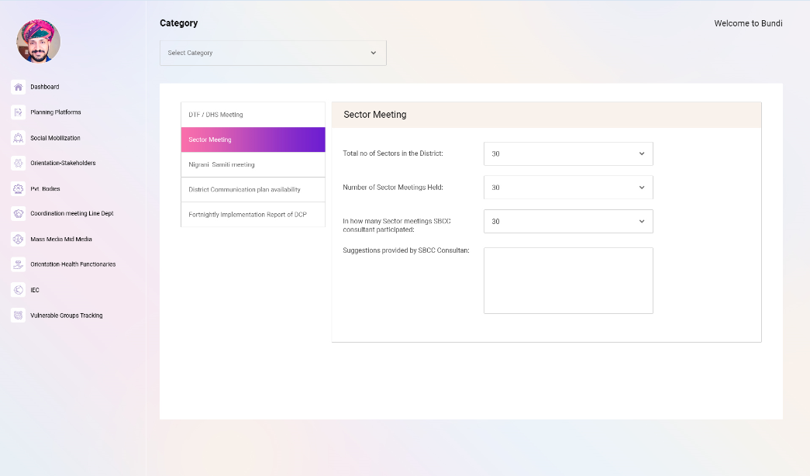

**Planning Platform >> Nigrani Samiti Meeting :**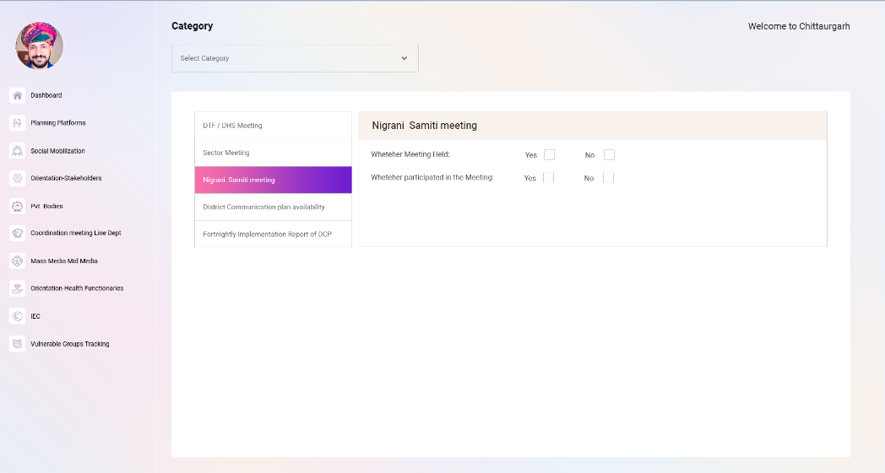

**Dashboard Responsive:**

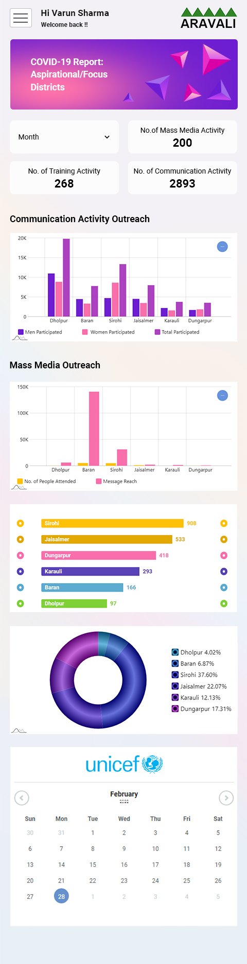

**Planning Platform >> DTF/DHS Meeting Responsive:**

